A study on inertia weight schemes with modified particle swarm optimization algorithm for multiple sequence alignment

Soniya Lalwani^{1, 3}, Rajesh Kumar², Senior Member, IEEE, Nilama Gupta³
¹ R & D, Advanced Bioinformatics Centre, Birla Institute of Scientific Research, Jaipur
² Department of Electrical Engineering, Malaviya National Institute of Technology, Jaipur
³ Department of Mathematics, Malaviya National Institute of Technology, Jaipur
email: slalwani.math@gmail.com, rkumar.ee@gmail.com, guptanilama@gmail.com

Abstract— In this study a modified particle swarm optimization (MPSO) algorithm has been proposed for obtaining optimal multiple sequence alignment (MSA). Due to the NP-complete nature of MSA problems, it is always a challenging task to obtain a suitable approach for optimal alignment of specific family of sequences. Proposed MPSO approach takes the random sequence length (with gaps), with non-repetitive gap positions in each iteration. Proposed approach applies both integer and binary matrix for incorporating gaps in sequences so as to avoid overlapping of gaps with sequences. Seven inertia weight schemes have been tested so as to check the effect of weight on convergence speed and time. Here the weight effect has been studied for different problem sizes i.e. 5 & 10 sequences with maximum sequence length of 10 & 212 respectively. MPSO is found to be performing well than standard PSO (S-PSO) at the same parameter set. Exponentially decreasing weight scheme is found performing significantly better at time and convergence criteria than other six weight approaches.
Keywords—Multiple sequence alignment, Particle swarm optimization, Inertia weight

introduction
Sequence alignment is the major research area of bioinformatics for sequence comparison. MSA is a substantial technique to discover functional, structural and evolutionary information in biological sequences. A stretch of the aligned sequences may represent the conserved region, responsible for evolutionary relationship between species and their ancestors. Conserved sub-regions may represent functionality or regulatory elements. MSA is essential for many bioinformatics applications i.e. structure prediction, function prediction, phylogeny and modeling binding sites.
A scheme of comparing two or more sequences in order to substitute alike characters in the same column is known as sequence alignment. Gaps are placed in the alignments in such a way that it may result in maximum number of character matches. If non-alike characters are placed in the same column then it is considered as a mismatch, whereas alike characters in same column is considered as match. If two sequences are being aligned then it’s a pairwise alignment, for more than two sequences it’s multiple sequence alignment (MSA). A precise classification of sequence alignment produces two types: local and global. In local alignment stretch of sequence with highest matches is aligned, whereas in global alignment entire sequence is aligned [1].
The methods to solve MSAs are divided into six categories: Exact approach; Progressive approach; Consistency based approach; Iterative approach. The fundamental example of exact approaches is dynamic programming (DP) [2]. In DP firstly a two dimensional alignment path matrix is created for pairwise alignment. Then the matrix is filled by stepwise calculation of score values & the optimal path is evaluated. The same procedure is followed for each pair. Although many variants have been defined in exact approach, still this approach is not efficient at time and accuracy aspects. Progressive approach constructs an alignment with most similar sequences first and incrementally aligns lesser similar sequences. The most preferred method based on this approach is ClustalW [3]. But, this method has problem of being dependent on initial pairwise alignment & requirement of appropriate scoring scheme. Consistency based approaches try to achieve the maximum consensus optimal pairwise alignment within the created library of alignments of provided sequences. T-COFFEE [4] & DIALIGN [5-6] are the most popular methods working at consistency based approaches. But the cost of accuracy is a high time complexity for this approach. Iterative approaches keep on iterating to improve obtained solution until the stopping criteria has not been achieved. These techniques include hidden Markov model training [7], simulated annealing [8], evolutionary algorithms and swarm intelligence (SI) techniques [9]. Iterative approach based algorithms generally take long time to converge towards solution. Hence, the objective taken in this paper is to improve the convergence speed of the algorithm in lesser time. For this purpose SI based technique, particle swarm optimization (PSO) with modifications has been proposed.
A classified review of literature of all the PSO based approaches for MSA can be found in [10]. In [11] the effect of linear (increasing & decreasing) and constant inertia weight was evaluated. They found that changing the weight scheme makes non-significant impact on optimal alignment. They found constant weight scheme (w=0.729844) to be suitable for standard PSO (S-PSO), depicting no influence of weight. They didn’t put consideration on the exponential inertia weight scheme. This study concentrates on two aims: checking the suitability of MPSO over S-PSO for optimal MSA at the S-PSO’s default parameters; comparison of performance of constant, linear, nonlinear and exponential weight schemes with respect to time, score and convergence speed.
The work is classified as follows: section II gives the introduction and algorithm of PSO, section III delineates MSA basics. Section IV summarizes the specifics of weight schemes. Section V carries the details of Modified PSO (MPSO) algorithm, along with the changes incorporated in algorithm for optimal MSA and procedure flow. Section VI discusses the results obtained followed by the conclusions in section VII.

particle swarm optimization
Swarm intelligence refers to the intelligent behaviour of swarms. Swarms perfectly systematize without any centralize control structure, during accumulating for their basic needs. This behaviour was simulated to develop a number of SI based algorithms in the area of artificial intelligence. PSO is one of these SI based algorithms, which is a global optimization, population-based computational method, inspired by social behavior of bird flocking or fish schooling. This derivative-free class of methods was derived by Kennedy and Eberhart in 1995 [12]. In PSO a function is needed to be minimized, tending to find a parameter set for objective:
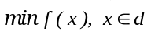 
where is a vector with dimension d. 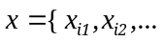 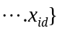for particle i = 1, 2, … n (n is number of particles). In a search space of d dimensions and n particles, for i^{th} particle at a particular position x_{i} (x_{i1}, x_{i2}… x_{id}), moving with a velocity v_{i} (v_{i1}, v_{i2} …v_{id}). Each particle has its personal best i.e. pbest as p_{i} (p_{i1}, p_{i2} …p_{id}), which is defined by its own best performance in the swarm. Similarly, an overall best performance of the particle with respect to the swarm defined global best is gbest. Each particle modifies its position using the particles current positions & velocities and distance between the current position from pbest & gbest. The movement of the particle is governed by updating its velocity and position attributes.

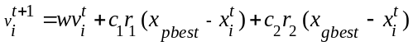 (2)

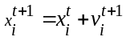 

where w = inertia weight, c₁ = cognitive acceleration coefficient, and c₂ = social acceleration coefficient, r₁ and r₂ are the random values between 0 and 1, x_{pbest} is the personal best of the particle and x_{gbest} is the global best of the particle. 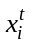 is the current position of i^{th} particle at iteration t. is the velocity of i^{th} particle at iteration t [13].
Here x_{pbest and} x_{gbest} and are updated using the following equations.
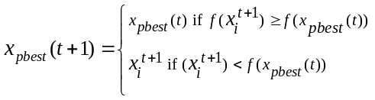 (4)

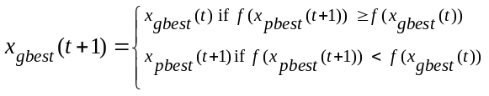 (5)

multiple sequence alignment
As discussed in introduction section, MSA refers to optimal allocation of gaps so as to maximize matches and minimize gaps. For scoring the matches & mismatches, a number of score schemes are available i.e. PAM and BLOSUM matrices (for protein). Here we have used the similarity scoring pattern based on the scoring scheme used in [11]. The objective is:

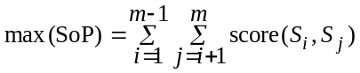 
subject to:
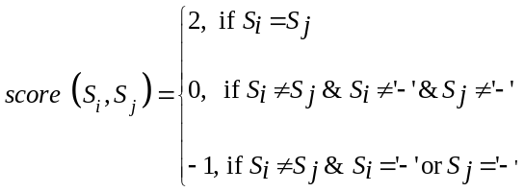 

Here the SoP refers to sum of pairs for all ^{m}C₂ pairs of sequences. As clear from (7), for each match the score is 2, for mismatch score is 0, for gap its -1. A number of gap penalty models are available. The gap penalty model used here is one of the most popular affine gap penalty model:

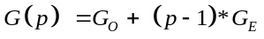         

Here p is the length of a continuous/single gap. G refers to gap penalty, G_{O} stands for gap opening penalty and G_{E} for gap extension penalty. For each opening gap the penalty assigned is -2 and for extending a gap, penalty is -1.

proposed weight schemes
Inertia weight plays crucial role in PSO for optimal solution efficiently, because it decides the control over global and local exploitation. During literature survey a few studies have been found regarding the influence of inertia weight on PSO. In [14] constant, time-varying and global-local best inertia weight schemes were applied for solving the optimal control of single-stage hybrid manufacturing systems. They found global-local best inertia weight scheme performing well, although exponentially decreasing strategy was not taken into consideration. In [15] adaptive crossover rate of differential evaluation algorithm concept was applied for the adaptive inertia weight. In [16] two exponential weight strategies were considered and compared with linear weight strategy. So far no studies have been found regarding the influence of weight schemes on MSA. Hence, seven weight schemes i.e. constant (C), decreasing linearly (DL), increasing linearly (IL), decreasing nonlinearly (DN), increasing nonlinearly (IN), decreasing exponentially (DE), increasing exponentially (IE) have been tested for optimal alignment. The parameters of all weight schemes are shown in Table I. Here t is the iteration number and q is total number of iterations. The tendency of weight increment and decrement is based on formulae as shown in Table I:
- Weight schemes
Weight Scheme | Formulae
Constant (C) | 0.729844
Increasing linearly (IL) | wo=0.9; wf=0.4  w=wf + aa  aa=aa+0.0007
Decreasing linearly (DL) | wo=0.9; wf=0.4  w=wo - aa  aa=aa+0.0007
Increasing nonlinearly (IN) | wo=0.9; wf=0.4  w=wo-((wo-wf)/t)
Decreasing nonlinearly (DN) | wo=0.9; wf=0.4  w=wf + ((wo-wf)/t)
Increasing exponentially (IE) | wo=0.9; wf=0.4; t=1000  w=wf + ((wo-wf) /(-exp (t /q))
Decreasing exponentially (DE) | wo=0.9; wf=0.4; t=1000  w=wo-((wo-wf) / (-exp (t /q))

As per author’s knowledge these seven weight schemes are compared first time, specially first time for MSA problem. The improvement in performance of MSA problem regarding weight strategy is discussed in next sections.

modified pso for msa
There are a number of approaches proposed to decide the maximum allowed length of sequence. Some authors suggest it to be 0.5 times the longest sequence and some suggest 0.2 times [17]. Some authors apply it as accordance to the average pairwise sequence identity (APSI) score and some apply according to similarity score of the sequences. To solve this issue maximum sequence length (µ) is taken in random form i.e. the maximum sequence length with gaps (α) is calculated by 0.2 times the length of longest sequence (β):

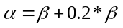 

In MPSO, µ is defined as a random value between β and α, for each iteration by following:

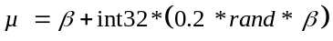 (

Whenever the position matrix is updated, it has the repeated gap positions. To maintain diversity, unique random gap positions are generated whenever the algorithm produces repeated gap positions.
Proposed scheme applied binary and integer variables in the same algorithm. Updated gap positions obtained are incorporated in binary form in the position matrix and then in sequence, whereas 0 stands for a gap and 1 stands for nucleotide. This strategy is helpful in avoiding the replacement of nucleotide by gap. Then PSO is applied on gap position matrix for optimal alignment.
Proposed algorithm is depicted by Fig. 1. After loading the fasta file and separating the sequence from its header file, all sequences are saved in one string i.e. S. Here if the sequences are of unequal length then at initial step the gaps are inserted at end of the sequences to make the length of S as β. All parameters i.e. swarm size, number of iterations, social & cognitive coefficients, inertia weight, gap positions, pbest, gbest and velocity are initialized. The initial gap positions are taken random and initial velocity is zero. Then random sequence length for individual swarm is generated.
Now the non repetitive gap positions are generated to maintain algorithm diversity. If any random value (w. r. to µ) in gap position matrix X is repeated, then MPSO generates a new random variable corresponding new gap position. Now, the non repetitive gap position matrix X generates binary matrix G giving 0 to gap and 1 to nucleotide. In next step G creates a new alignment for the sequences. Now the alignment score is calculated, which is the value of f (x) in (1).
The resultant f (x) is used to update the particle best and global best using 4 & 5. Now with new pbest and gbest the velocity and position are updated. The process is repeated until the stopping criteria (i.e. maximum no of iterations or convergence criteria) have not met. Here the convergence repetition of a solution for 50 consecutive times.

Load n sequences in fasta format and save all in S
Create a swarm of size m
Initialize position matrix X, velocity matrix V, pbest and gbest
x_{i}(0) = int32(rand*(µ)) i {1, . . . , m}
v_{i}(0) ← 0, i {1, . . . , m}
t ← 0
repeat:

for all particles i {1, . . . , m} do:
Create random sequence length by (10)
Check for non repetitive gap positions and update X
Incorporate all gap positions of matrix X in matrix G
Incorporate gaps in S
Find out the value of objective function in (1) using (6)
Update pbest and gbest using (4) & (5)
Update velocity using (2)
Update gap position using (3)
end for

t ← t +1
until stopping criteria is met

- Multiple Sequence Alignment using MPSO algorithm

experimental setup
The sequence sets taken for testing are S1 and S8. S1 set contains 10 sequences of Hepatitis C virus type 1b RNA accessed from site of national center for biotechnology information (ncbi) (accession numbers: Z75841.1, Z75850.1, Z75853.1, Z75859.1, Z75860.1, Z75861.1, Z75854.1, Z75852.1, Z75851.1, Z75858.1) with average sequence length 211 and longest length 212 [18]. S8 set contains 5 RNA sequences with average sequence length 8 and longest length 10. S8 was artificially generated by [11] for testing the efficiency and accuracy of their algorithm. Maximum length of sequence with gaps using (9) is 254 for S1 and 12 for S8. The default parameters taken for PSO are the same as that of S-PSO except the weight strategy. The number of particles taken in a swarm is 25. Number of iterations is 1000. Each weight strategy has 40 simulation runs. The neighbourhood topology applied is Lbest topology. No clamping on velocity is applied. The cognitive coefficient c₁ and social coefficient c₂ are taken 1.496180. MATLAB programming environment has been used. The system configuration is Sun microsystems workstation Ultra 20 with RAM 2GB, processor AMD Opteron and operating system Ubuntu.

results and discussions
The results obtained by all seven weight based variants of MPSO are represented in Table II. The results are in terms of score and time in order of weight strategy applied, basic parameters i.e. time (in seconds) & similarity score, the mean score and mean time of all 40 simulations, the standard deviation (SD) between obtained scores, minimum (Min) and maximum (Max) scores obtained respectively. The notable conclusion of table II is shown by Fig. 2, 3 and 4 by depicting the comparison between all the seven weight strategies.
Table III shows the comparison of MPSO, S-PSO results for S8. For S-PSO the time taken by the simulation run has not been considered and also minimum score is also not shown. Hence, those parts are not compared in this table. For S-PSO the results were considered optimal for constant weight scheme. It can be observed that MPSO has shown remarkably better results than S-PSO even at constant weight scheme and far better at DE scheme. MPSO has comparatively more SD than S-PSO for nearly all weight schemes. This could be a future area for improvement in MPSO.
Now, if the results are compared with one of the most popular sequence alignment tool ClustalW2, which works at progressive approach. The scoring scheme applied by MPSO and S-PSO differs from ClustalW2. So the similarity score of optimal alignment obtained from ClustalW2 has been calculated by proposed scoring scheme. Also, number of total matches and number of total column matches is calculated for better comparison. The result with ClustalW2 is: number of gaps 8, number of matches 45, number of total column matches 2 and similarity score 49. The optimal results obtained by MPSO & S-PSO are: number of gaps 8, number of matches 48, number of total column matches 3 and similarity score 55, showing better results than ClustalW2.
It is clear from Fig. 2 that DE strategy is more frequent to produce maximum score than other six strategies. DE obtained optimal score 29 time, whereas DN and IE are the second obtaining optimal score 22 times each. The same superiority can be observed in Fig. 3 that DE scores have highest average score. The minimum highest score is produced by IL. The maximum score is same for all weight strategies, which shows that every strategy obtained the optimal alignment at least once.
Fig. 4 presents the time consumption by all seven weight strategies. It can be observed that the mean time taken by DE is notably the lowest one. The mean time taken as well as the mean score obtained by all weight strategies is significantly different as calculated by one way ANOVA as shown by Table IV.
Fig. 5 & 6 represent the remarkable influence of different weight strategies for different number and length of sequences i.e. convergence rate for different set of sequences. Fig. 5 shows the convergence comparison for S8 sequences, with µ=10, m = 5 and α= 12. Fig. 6 shows the comparison for S1 sequences with µ= 212, m = 10 and α = 254. It can be observed that DE scheme converges towards solution earliest followed by DN. The justification towards this tendency is during the starting part of the search, larger weight allows using the complete search space. This helps in determining the location of the optimal solution. During the latter part of the search, since the algorithm is converging to the optimal solution, smaller weight finds the global optima fast.

- Comparison of time, number of matches, number of gaps, number of full matched columns and similarity score for different weight schemes for S8

Weight scheme | Parameter | Mean | SD | Min | Max
Constant | Time | 21.3059 | 2.8319 | 19.7916 | 34.7198
Constant | Sim score | 52.9333 | 4.47162 | 43 | 55
Increasing Linearly | Time | 21.2896 | 3.2233 | 19.5988 | 33.4983
Increasing Linearly | Sim score | 50.78 | 3.3936 | 39 | 55
Decreasing Linearly | Time | 21.4692 | 3.4671 | 19.1705 | 35.0251
Decreasing Linearly | Sim score | 52.6 | 4.51 | 39 | 55
Increasing Nonlinearly | Time | 21.1281 | 3.8272 | 19.2272 | 38.3359
Increasing Nonlinearly | Sim score | 52.8714 | 3.9281 | 45 | 55
Decreasing Nonlinearly | Time | 20.6125 | 0.9161 | 19.2632 | 24.0936
Decreasing Nonlinearly | Sim score | 53.1333 | 3.7 | 41 | 55
Increasing Exponentially | Time | 20.6294 | 5.5141 | 6.2351 | 45.8189
Increasing Exponentially | Sim score | 53.0713 | 3.8762 | 45 | 55
Decreasing Exponentially | Time | 17.8619 | 6.6708 | 2.8762 | 45.8687
Decreasing Exponentially | Sim score | 53.9836 | 5.2543 | 37 | 55

- comparsion of results of s-pso , mpso and clustalw2 for s8

Approach | Weight scheme | Mean | SD | Max
S-PSO | Constant | 51.4 | 1.5794 | 55
MPSO | Constant | 52.9333 | 4.47162 | 55
MPSO | Decreasing Exponentially | 53.9836 | 5.2543 | 55
ClustalW2 | - | - | - | 49

- one way anova results of time and score based performance comparison between weight strategies for S8
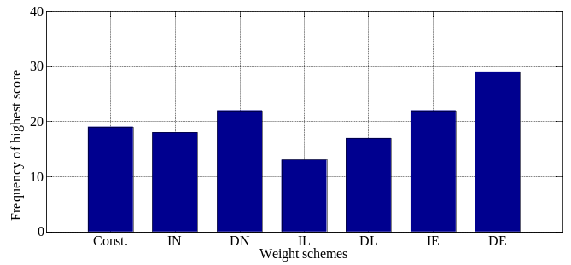
Parameters compared | F value  (df) | p value | Result
Score | 2.160 (6) | 0.047 | ` Significant
Time | 3.671 (6) | 0.002 | Very Significant
- No. of times the highest scores obtained with different weight schemes

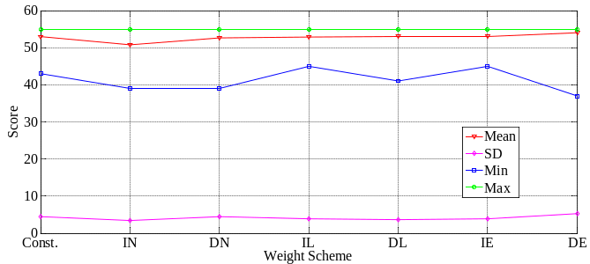
- Comparison between scores of different weight schemes

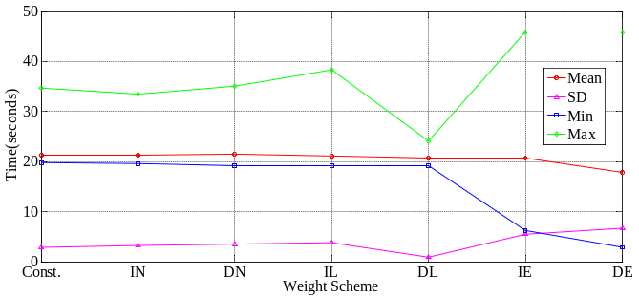
- Comparison between simulation time of different weight schemes

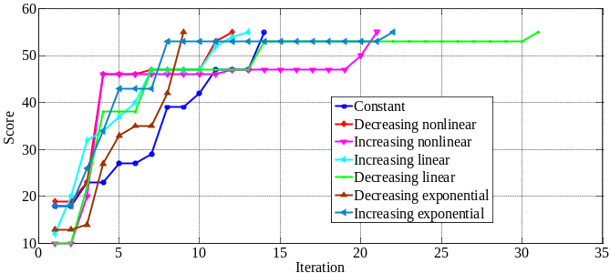
- Comparison of convergence rate for different weight schemes for S8

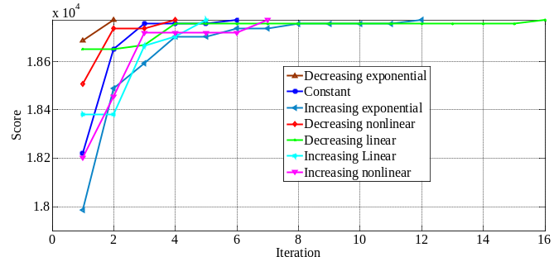
- Comparison of convergence rate for different weight schemes for S1

Conclusions
Proposed study is based on the influence of inertia weight schemes with modified PSO algorithm for MSA. All the seven inertia weight schemes are evaluated at four parameters i.e. minimum & maximum scores obtained, average score and standard deviation between the scores. The weight schemes with proposed algorithm are tested on S1 (10 sequences, longest length 212) and S8 (5 sequences, longest length 10) sequence sets for optimal MSA. The objective is to maximize the similarity score. DE approach is found to be performing well in all aspects, as can be seen in Fig. 2, 3, 4 and Table II, III, IV. The next better performance was of DN approach. The difference between average score obtained by using different weight strategies is found significant (p=0.047) as calculated by one way ANOVA. Hence the average scores obtained by exponentially decreasing weight scheme are significantly better than the other six weight strategies. Although score optimization is the only objective but at time constraint too DE are found to be performing significantly fast (p=0.002). The modified PSO has not fixed α, which opens the scope to have the random sequence length. The algorithm used non repetitive gap positions strategy so as to improve diversity. It used binary matrix to insert gap to avoid overlapping and replacement of nucleotides by gaps. The further work could be done on multi-objective optimization for maximization of score and minimization of gaps. Although, the algorithm has been tested on different inertia weight combinations, yet more combination can be tested for more optimal results. The algorithm produces large variation between results i.e. large SD, which needs to be improved. Also, this algorithm needs improvement towards time and stacking in local optima problems of PSO.

Acknowledgment
The authors wish to thank the Executive Director, Birla Institute of Scientific Research for the support given during this work. We are thankful to Dr. Krishna Mohan for his valuable suggestions throughout the work. We gratefully acknowledge financial support by BTIS-sub DIC (supported by DBT, Govt. of India) to one of us (S.L.) and Advanced Bioinformatics Centre (supported by Govt. of Rajasthan) at Birla Institute of Scientific Research for infrastructure facilities for carrying out this work.

References
- Mount DW, Bioinformatics Sequence and Genome Analysis, Second Edition, Cold Spring Harbor Laboratory Press, 2004.
- Needleman SB and Wunsch CD, “A general method applicable to the search for similarity in the amino acid sequences of two proteins”, Journal of Molecular Biology, vol. 48, 1970, pp. 443-453.
- Thompson JD, Higgins DG and Gibson TJ, “CLUSTAL W: improving the sensitivity of progressive multiple sequence alignment through sequence weighting, position-speciﬁc gap penalties and weight matrix choice”, Nucleic Acids Research, vol. 22, 1994, pp. 4673-4680.
- Notredame C, Higgins DG and Heringa J, “T-COFFEE: a novel method for fast and accurate multiple sequence alignment”, Journal of Molecular Biology, vol. 302(1), 2000, pp. 205-217.
- Morgenstern B, “DIALIGN 2: improvement of the segment-to-segment approach to multiple sequence alignment”, Bioinformatics, vol. 15(3), 1999, pp. 211-218.
- Subramanian AR, Menkhoff JW, Kaufmann M and Morgenstern B, “DIALIGN-T: an improved algorithm for segment-based multiple sequence alignment”, Bioinformatics, vol. 6, 2005.
- Durbin R, Eddy S, Krogh A and Mitchison G, “Biological Sequence Analysis: Probabilistic Models of Proteins and Nucleic Acids”, Cambridge University Press, United Kingdom, 1998.
- Kim J, Pramanik S and Chung MJ, “Multiple sequence alignment using simulated annealing”, Computer Applications in the Biosciences, vol. 10(4), 1994, pp. 419-426.
- Chen Y, Pan Y, Chen J, Liu W and Chen L, “Multiple sequence alignment by ant colony optimization and divide-and-conquer”, Computational science-ICCS 2006, Lecture notes in computer science, Springer-verlag, 3992, 2006, pp. 646-653.
- Lalwani S, Kumar R, Gupta N, “A Review on Particle Swarm Optimization variants and their applications to Multiple Sequence Alignment”, Journal of Applied Mathematics and Bioinformatics, vol. 3(2), 2013, pp. 87-124.
- Zablocki FBR, “Multiple sequence alignment using Particle swarm optimization”, MS dissertation, University of Pretoria, 2007.
- Kennedy J and Eberhart R, “Particle Swarm Optimization”, IEEE International Conference on Neural Networks, 4, 1995, pp. 1942-1948.
- Lalwani S, Singhal S, Kumar R, Gupta N, “A Comprehensive Survey: Applications of Multi-Objective Particle Swarm Optimization (MOPSO) algorithm”, Transaction on Combinatorics, vol 2(1), 2013, pp. 39-101.
- Arumugam MS and Rao MVC, “On the performance of the particle swarm optimization algorithm with various inertia weight variants for computing optimal control of a class of hybrid systems”, Discrete Dynamics in Nature and Society, vol. 2006.
- Ting TO, Shi Y, Cheng S and Lee S, “Exponential Inertia Weight for Particle Swarm Optimization”, Advances in swarm intelligence, Lecture notes in computer science, vol. 7331, Springer-verlag, 2012, pp. 83-90.
- Chen G, Huang X, Jia J and Ming Z, “Natural Exponential Inertia Weight Strategy in Particle Swarm Optimization”, Proceedings of 6th World Congress on Control and Automation, 2006, pp. 3672-3675.
- Chellapilla K and Fogel GB, "Multiple sequence alignment using evolutionary programming," Proceedings of Congress on Evolutionary Computation, vol.1, 1999, pp. 445-452
- Zhang C and Wong AK, "A genetic algorithm for multiple molecular sequence alignment" Computer Applications in the Biosciences, vol. 13(6), 1997, pp. 565-581

